**TECHNICAL REPORT WRITING FOR CA#2 EXAMINATION**



**NAME**- SAPNADARSHI SINGHA

**STREAM**- COMPUTER SCIENCE AND BUSINESS SYSTEM

**YEAR**- SECOND (FOURTH SEMESTER)

**ROLL NUMBER**- 18731122014

**SUBJECT NAME**- ENVIRONMENTAL SCIENCE

**SUBJECT CODE-** MC 401

**REGISTRATION NO**- 221870110095

**SESSION-** 2022-2026

**DATE OF SUBMISSON**- 16/03/2024

**TOPIC-** Investigating the fate and transport of heavy metal contaminants in the environment

CONTENT PAGE

|  |  |  |
| --- | --- | --- |
|  | CONTENT | PAGE NO |
|  | TABLE OF CONTENT | 2 |
|  | ABSTRACT | 3 |
|  | INTRODUCTION | 4 |
|  | ANALYSIS | 5-9 |
| SOURCES OF HEAVY METALS |
| WAYS OF HEAVY METAL TRANSPORT |
| DIAGRAM 1 |
| FATE OF THE HEAVY METALS IN |
| ENVIROMENT |
| DIAGRAM 2 |
|  | CONCLUSION | 10 |
|  | REFERENCE | 11 |

ABSTRACT

Heavy metals are hazardous, persistent, and bio accumulative, posing serious risks to humans and the environment. Understanding the fate and transportation of pollutants is essential for effective environmental management. The fate and transportation of heavy metal

This report examines the fate and transport of heavy metal contaminants in the environment,

pollutants in the environment, including their origins, fate, transport, monitoring, case studies, and future perspectives

INTRODUCTION

Heavy metals are persistent environmental contaminants that can harm ecosystems and human health. Metals such as lead, mercury, cadmium, arsenic, and chromium are naturally occurring but have increased in the environment due to human activities like industrial processes, mining, agriculture, and waste disposal. Understanding the fate and movement of heavy metal pollutants is crucial for effective environmental management and public health.

Heavy metals released into the environment undergo a series of processes that determine their behaviour and dispersion. Metals are immobilized or transported within soil or bodies of water through physical processes like adsorption and sedimentation. Chemical processes like precipitation, complexation, and redox reactions affect the solubility and mobility of heavy metals, making them more accessible to living organisms. Biological mechanisms like bio-accumulation and bio-magnification increase the risk of heavy metal contamination by allowing higher trophic levels to acquire larger amounts of metal. Heavy metal contamination can originate from both natural and anthropogenic sources. Heavy metals can be released into the environment naturally through geological processes like weathering and volcanic eruptions. Heavy metal pollution is primarily caused by human activities. Industrial operations release heavy metals into the environment, and mining exposes previously buried metals. Agricultural activities, including the use of heavy metal fertilizers and pesticides, can lead to contamination.

According to their toxicity to living organisms, the heavy metals are arranged in the following order:

Hg > Cu > Zn > Ni > Pb > Cd > Cr > Sn > Fe > Mn > Al [3]

ANALYSIS

Analysing the fate and transport of heavy metal contaminants in the environment requires a multidisciplinary approach that incorporates various scientific disciplines such as environmental chemistry.

* SOURCES**:** Heavy metal contamination comes from a variety of sources, both anthropogenic (caused by humans) and natural.
* Natural Sources:

1. **Biogeochemical Cycling**: Heavy metals can be mobilized in the environment through natural processes such as biological decay, organic matter decomposition, or microbial activity. Plants, fungi, and microorganisms can absorb and accumulate heavy metals from soil and water, helping to regulate their natural cycling and distribution.
2. **Geological Processes**: Heavy metals are naturally occurring in the Earth's crust and can be released into the environment via geological processes such as weathering, erosion, and volcanic activity. Naturally occurring mineral deposits and geological formations may contain high concentrations of heavy metal.

* Anthropogenic sources:

1. **Industrial Activities:** Heavy metals enter the environment through a variety of industrial processes, including mining, smelting, metal plating, manufacturing, and the combustion of fossil fuels. These activities can emit heavy metals directly into the air, water, and soil.
2. **Agricultural Practices:** Agriculture's use of fertilizers, pesticides, and animal manure can introduce heavy metals into the soil and water. Contaminated agricultural runoff has the potential to transport heavy metals to surface and groundwater.
3. **Atmospheric Deposition:** Heavy metals emitted by industrial sources, vehicles, and other combustion processes can travel long distances through the atmosphere and settle on land and water surfaces. This atmospheric deposition contributes to heavy metal contamination of the soil, water bodies, and plants.
4. **Mining Processing:** Mining activities, such as ore extraction, processing, and transportation, have the potential to release significant amounts of heavy metals into the environment. Tailings, waste rock, and abandoned mine sites are all sources of contamination that can last for decades or centuries.

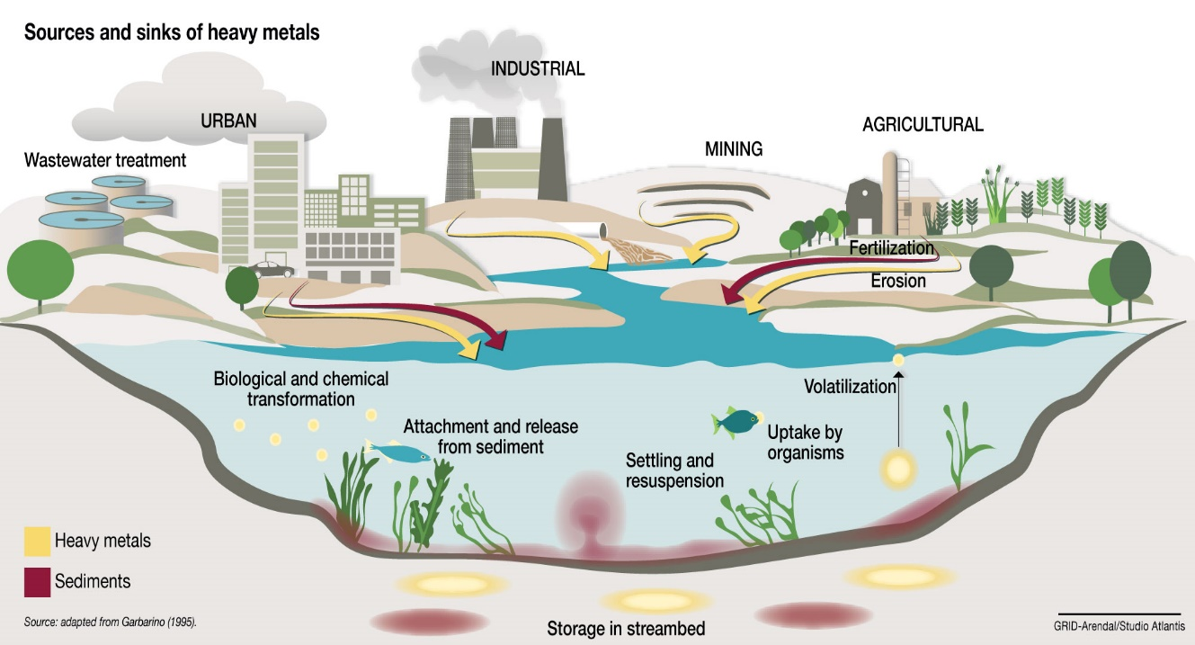

Understanding the sources of heavy metal contamination is critical for developing effective management and mitigation strategies that protect the environment and human health. By identifying and addressing the root causes of contamination, stakeholders can work toward long-term solutions to mitigate the effects of heavy metals on ecosystems and communities.

* WAYS OF HEAVY METALS TRANSPORT: Heavy metals can move through the environment in a variety of ways, including air, water, soil, and biota. Understanding these pathways is critical for assessing the potential risks of heavy metal contamination and developing effective management strategies.

1. **WATER TRANSPORT:**

Water is an important medium for the movement of heavy metals in the environment. Surface water bodies, such as rivers, lakes, and oceans, can become contaminated with heavy metals due to urban runoff, industrial discharges, and agricultural activities. Heavy metals from contaminated soils and sediments can also leach into groundwater, contaminating it. Heavy metals in water bodies can be transported downstream, affecting ecosystems and potentially endangering human health through drinking water contamination and bioaccumulation in aquatic organisms.

1. **ATMOSPHERIC TRANSPORT:**

Heavy metals can be released into the atmosphere from both natural and anthropogenic sources, including industrial processes, vehicle emissions, and volcanic activity. Once in the atmosphere, they can travel long distances through atmospheric currents before settling on terrestrial and aquatic surfaces via dry and wet deposition processes. Heavy metal deposition in the atmosphere has the potential to contaminate soils, surface waters, and vegetation, especially in areas near emission sources.

1. **SOIL TRANSPORT**:

Heavy metals can bind to soil particles and travel through erosion, surface runoff, and leaching processes. Rainfall, wind, and land use practices can all contribute to soil erosion, which can cause topsoil loss and the transport of heavy metal-contaminated sediments to nearby bodies of water. Surface runoff can also transport heavy metals from contaminated soils to surface waters, adding to aquatic pollution. Heavy metals can leach into groundwater under certain hydrological conditions, especially in areas with sandy soils and high precipitation rates.

1. **HUMAN TRANSPORT**:

Human activities can also contribute to the spread of heavy metals in the environment. Mining, smelting, and manufacturing can all emit large amounts of heavy metals into the environment, resulting in local and regional contamination. The transportation and disposal of industrial waste and sewage can also contribute to heavy metal pollution in soils, surface waters, and groundwater. Furthermore, improper handling and disposal of heavy metal-containing consumer products, such as batteries and electronic waste, can contaminate the environment and expose humans.

* FATE OF THE HEAVY METALS IN ENVIROMENT:

1. **ADSORPTION AND DESORPTION**

Heavy metals can adsorb to soil particles, sediment, and organic matter via electrostatic attraction, surface complexation, and ion exchange. Adsorption on solid surfaces reduces the mobility and bioavailability of heavy metals in the environment. However, under certain conditions, such as pH changes or the presence of competing ions, heavy metals can desorb from solid surfaces and regain mobility.

1. **PRECIPITATION AND DISSOLUTION**

Heavy metals can form insoluble precipitates with a variety of minerals, especially at high pH and redox levels. Precipitation reactions can immobilize heavy metals in soils and sediments, reducing their availability for uptake by plants and aquatic organisms. Precipitate dissolution, on the other hand, has the potential to release heavy metals back into the environment, especially in acidic conditions or when chelating agents are present.

1. **COMPLEXTATION AND SPECIATION**

Heavy metals can form complexes with organic and inorganic ligands in the environment, affecting their chemical speciation and reactivity. Complexation reactions can have an impact on heavy metal solubility, mobility, and toxicity, as well as their bioavailability to living organisms. Heavy metal speciation is influenced by pH, redox potential, temperature, organic matter, and ligands.

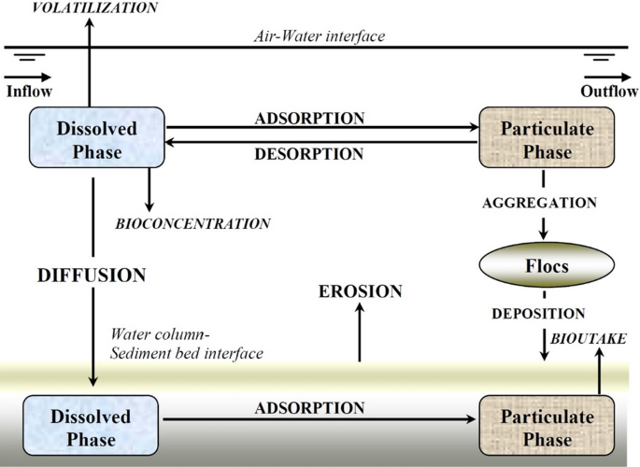

1. **TRANSPORTATION AND REDISTRIBUTION**

Heavy metals can move within and between environmental compartments such as soil, water, sediment, and biota via physical processes like erosion, leaching, runoff, and groundwater flow. Transport pathways can cause heavy metals to be redistributed across spatial and temporal scales, resulting in long-term contamination and potential risks to human health and ecosystems.

1. **BIOLOGICAL PROCESS**

Heavy metals can move within and between environmental compartments such as soil, water, sediment, and biota via physical processes like erosion, leaching, runoff, and groundwater flow. Transport pathways can cause heavy metals to be redistributed across spatial and temporal scales, resulting in long-term contamination and potential risks to human health and ecosystems.

CONCLUSION

The study examines the environmental impact of heavy metal contaminants, focusing on the interactions between natural processes, human activities, and environmental pathways. To address heavy metal contamination, it's important to take a holistic approach that includes scientific knowledge, regulatory measures, and sustainable practices due to its persistence and bioaccumulation.  
Physical, chemical, and biological processes all influence the behavior and impacts of heavy metals.  
Metal mobility is affected by physical processes such as adsorption and sedimentation, while solubility and toxicity are influenced by chemical reactions. Biological processes raise exposure risks. Metal distribution is influenced by various transport pathways, including soil-water interactions, atmospheric deposition, and aquatic transport. Human-induced mechanisms such as industrial discharges and global trade also have an impact.

Effective methods for monitoring and assessing heavy metal contamination, including sampling and risk assessment, are necessary. Regulatory standards establish acceptable levels of compliance with regulations. Stakeholders such as scientists, policymakers, industries, and communities work together to prioritize pollution prevention, remediation technologies, sustainable practices, and public awareness.   
The study on heavy metal contaminants' fate and transport sheds light on the complexities of environmental pollution, highlighting the importance of taking proactive measures to protect ecosystems and human health.

**REFERENCE**

1. [**https://www.intechopen.com**](https://www.intechopen.com)
2. [**https://www.researchgate.net/figure/Source-and-Fate-of-Heavy-Metals-in-the-Soil-and-Environment_fig2_323303412**](https://www.researchgate.net/figure/Source-and-Fate-of-Heavy-Metals-in-the-Soil-and-Environment_fig2_323303412)
3. https://www.ncbi.nlm.nih.gov/pmc/articles/PMC7490536